**ST.XAVIER,S COLLEGE**

**Maitighar, Kathmandu**



Digital Logic Lab Assignment #1

**Draw the checkbox.**

Yub Raj Basnet

013BScCSIT048 (4th Semester)

**Submitted to**

|  |  |
| --- | --- |
| Er. Anil Sah  (Lecturer, St.Xavier’s College ) |  |

**Submitted date: Aug 14, 2015**

# Draw the following checkboard

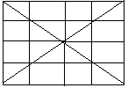

**Source Code**

//---------------------------------------------------------------------------

#include <vcl\vcl.h>

#pragma hdrstop

#include "Unit1.h"

//---------------------------------------------------------------------------

#pragma resource "*.dfm"

int x=100,i=1,y=50;

TForm1 *Form1;

//---------------------------------------------------------------------------

__fastcall TForm1::TForm1(TComponent* Owner)

: TForm(Owner)

{

}

//---------------------------------------------------------------------------

void __fastcall TForm1::Button1Click(TObject *Sender)

{

Form1->Canvas->Pen->Width=3;

Form1->Canvas->Brush->Color=clWhite;

Form1->Canvas->Rectangle(10,10,400,200);

do{

Form1->Canvas->MoveTo(i*x,10);

Form1->Canvas->LineTo(i*x,200);

Form1->Canvas->MoveTo(10,y*i);

Form1->Canvas->LineTo(400,y*i);

i++;

}while(i!=4);

Form1->Canvas->MoveTo(10,10);

Form1->Canvas->LineTo(400,200);

Form1->Canvas->MoveTo(400,10);

Form1->Canvas->LineTo(10,200);

}

//---------------------------------------------------------------------------

# Output



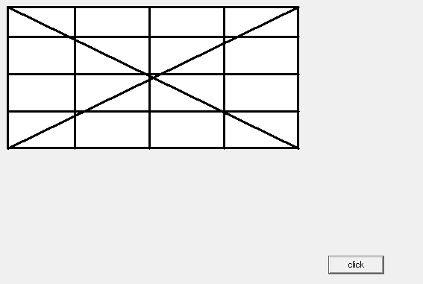

# Reference

[1] Er.Anil Sah,”Builder1”